
Company
Logotype

Cone Beam Computed Tomography- Report



Porur Dental X-rays & CBCT

Patient Name : Mrs. Dayana Rexalin | Date of Report : 08.08.2024
Age/ Gender : 38 years/ Female | Region of Interest : CBCT Sectional Maxilla
Referring doctor: Dr. Selva Ganesh | Indication : Assessment of 14
Clinical Notes: Nil
PATIENT INFORMATION

CBCT- Sectional Maxilla provided
CBCT – IMAGE DETAILS

RADIOGRAPHIC INTERPRETATION

- Retained deciduous tooth: 53
- Horizontally impacted tooth 13 appears to be in contact with the floor of the nasal cavity.
- In relation to 14, presence of hyperdense restorative material involving the crown and extending partially into the buccal and palatal root canal upto the apical third is evident.
- In relation to the periapical aspect of 14, presence of mild area of hypodensity, with diffuse margins is evident.
- Distance between the apical third of 14 and the impacted 13 is 1.15 mm

RADIOGRAPHIC IMPRESSION

- Incompletely root canal treated tooth: 14 with periapical pathology.
- Impacted tooth: 13; Retained deciduous tooth: 53.

Kindly correlate with clinical findings


IMAGES FOR REFERENCE

RECONSTRUCTED PANORAMIC VIEW
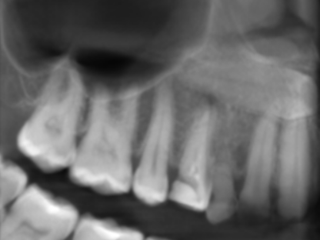

3-DIMENSIONAL VIEW

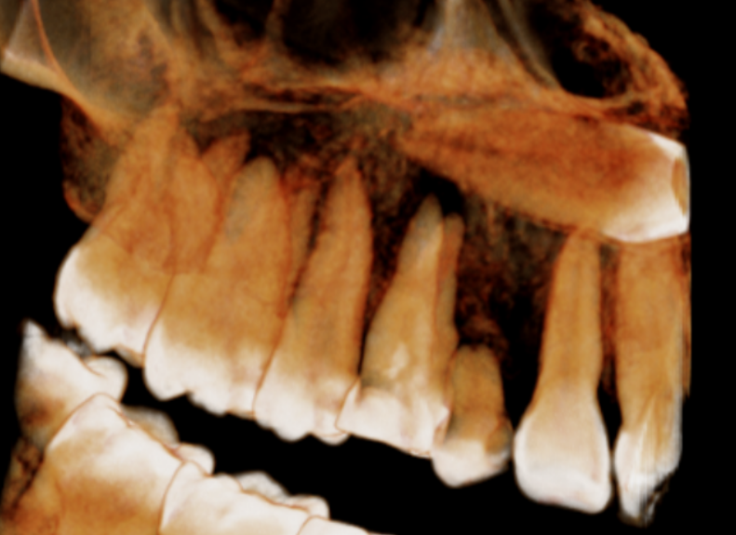

CROSS SECTIONAL VIEW

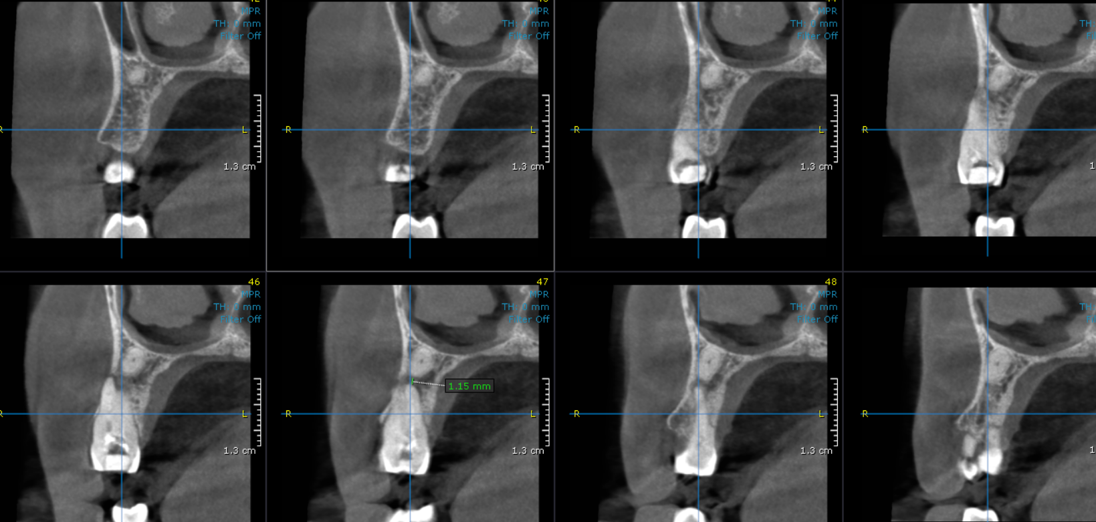

**** End of report ****

